1. **EXECUTION – PM - section**

* Principle: when the Sales closes the Opportunity as won (*“Close as Won” button)* the CRM sends the project to the Head of Project Management with an alert; He then assigns a PM for this project and the CRM grants access to that PM over this particular project only;

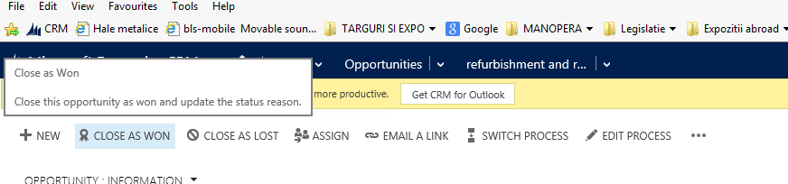

* Users for this section:
  + Head of PM for all projects
  + 8 PMs for the projects assigned to them.
* Necessary fields in this section:
  + - PM assigned to choose from the 8 PM existing (Head of PM sets that); The rest is filled by the PM himself:
    - Start date of the project;
    - Deadline of the project;
    - Cost Section: they will enter here all subcontractors they work with for that project:

|  |  |  |  |
| --- | --- | --- | --- |
| Name of Subcontractor | Cost | Type of works (to choose from M&E, constructions, other works) | Comments |
|  |  |  |  |

* + - Section for supplementary works: they need to have the possibility to make an update of the entire value – the costs for these supplementary works will be mentioned in the above;
    - Date of official project Hand-Over to client;
    - Warranty offered to the client (very useful for Service Dept)
* Button to close the project as *COMPLETED*